|  |  |  |
| --- | --- | --- |
| Project Team |  |  |
| Rozalina Miladinova 3285588  Aleksandar Georgiev 3229742  Nidhi Sharma 3233006  Nguyen Bao Quoc 3477347  Sander Van Bemmel 3261107  Fares Alsalama 3396029 |  |  |

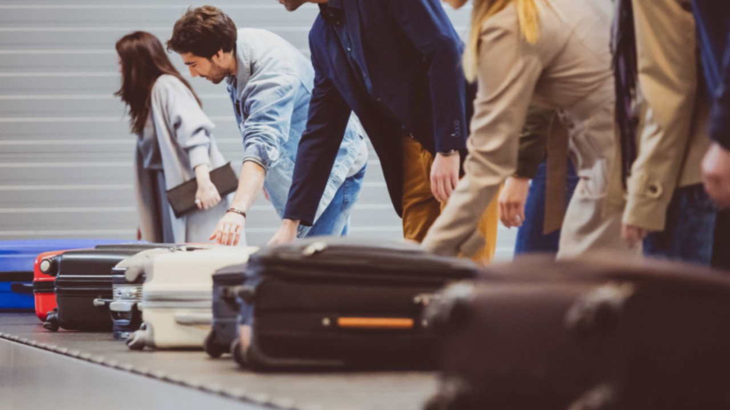

**Airport baggage simulator**

**Process Report**

|  |
| --- |
|  |

Contents

Global Work Division 3

# Global Work division

##### **Week 2 – Minutes**

|  |  |
| --- | --- |
| Location: | 2.50 |
| Date: | 10/09/2019 |
| Time: | 12:00 – 12:30 |
| Attendees: | Rozalina Miladinova  Aleksandar Georgiev  Nidhi Sharma  Nguyen Bao Quoc  Sander Van Bemmel  Fares Alsalama |

## Topic:

* Introduction of the project

## Discussion:

* What the project is about
* Feedback on project plan draft
* Current situation, problems, desired end situation

## Agreed To:

* Working on the final version of the project plan
* Begin working on the user requirements document

##### **Week 2 – Who did what?**

|  |  |  |
| --- | --- | --- |
| Responsibility of | Activities | Time spent |
| Nidhi Sharma | * Work on project plan * Minutes writing * Create the process report |  |
| Rozalina Miladenova | * Work on project plan * Agenda writing |  |
| Aleksander Georgiev | * Brainstorming ideas for the application |  |
| Ngyuen Bao Quoc | * Agenda writing * Work on the User Requirements document * Research on the to be implement algorithm |  |
| Fares Alsalama | * Work on the User Requirements document |  |
| Sander Van Bemmel | * Brainstorming ideas for the application |  |

## 